LAB 3

Problem 5.1

1. CODE PROVIDED
2. CODE TESTING parts 1 and two
   1. Part 1

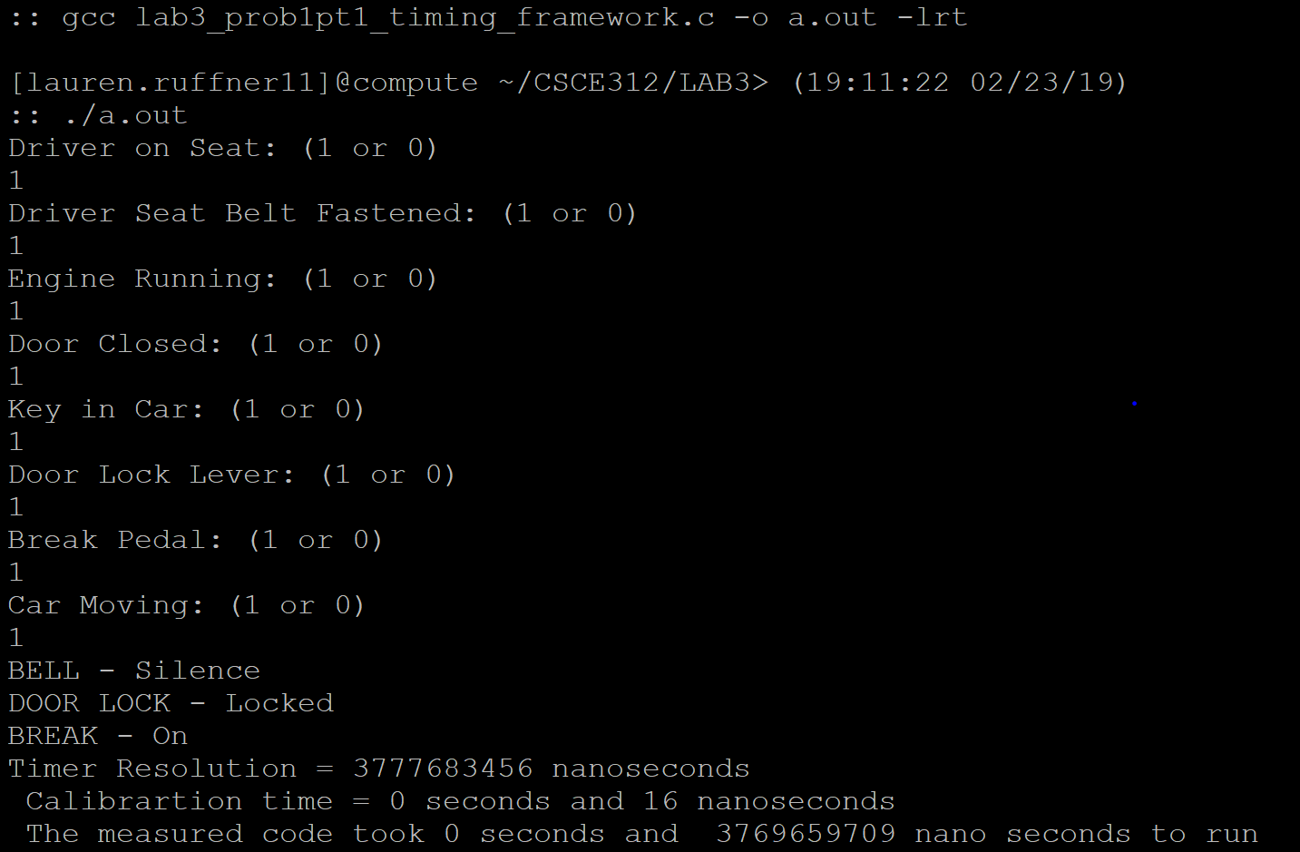

* 1. Part 2

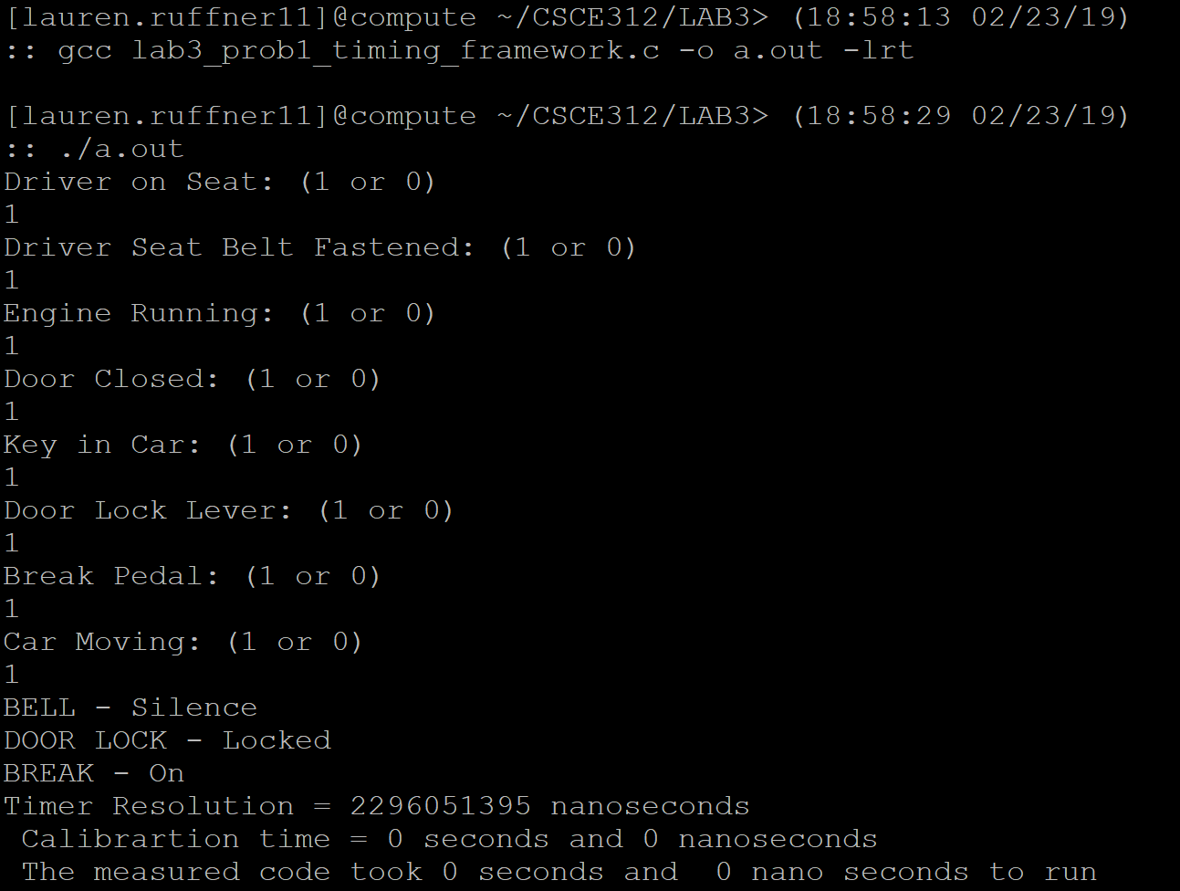

1. CODE TESTING Lab 1
   1. 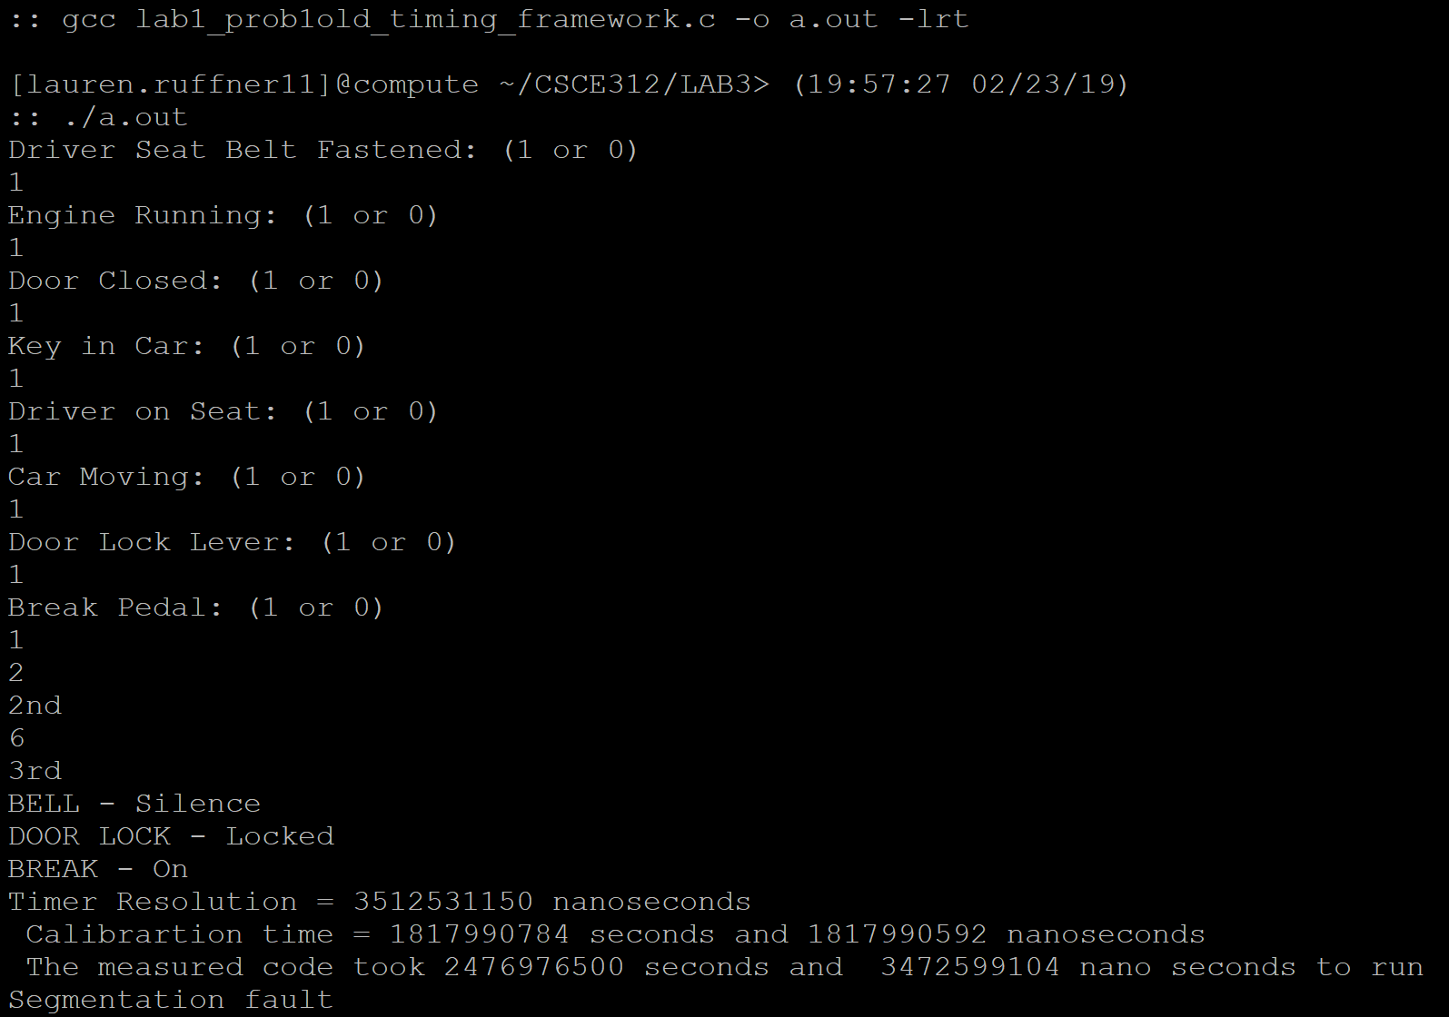
   2. My code took longer than the second way but not the first way
2. My code takes longer for certain circumstances especially the ones where multiple actuators are turned on. That is because for each one to turn on you have to go through a comparison. For you to turn on all 3 actuators, there’s 3 conditionals to go through in my code. In the 2nd option of the new ones you only fulfill one case which makes it faster.
3. The only way to make my original code more efficient is to almost completely turn it into the new option so it only looks for a single case.

Problem 5.2

1. SPST - Single Pole, Single Throw
   1. Pole (number of switch contact sets)
   2. Throw (number of conducting positions

NO- Normally Off

1. 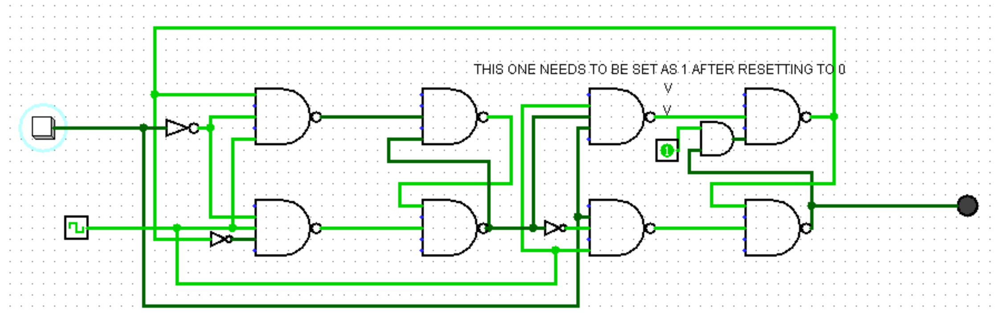
2. 8 nand gates 1 and gate 3 inverters

4 nand with 3 inputs 4 with 2 inputs

* 1. 1 Hex Inverter gate (SN74LS04) 74x04
  2. 1 quad 2-input NAND gate (SN74LS01)74x01
  3. 2 dual 4-input NAND gate (SN74LS20) 74x20
  4. 1 quad 2-input AND gate (SN74LS03) 74x08

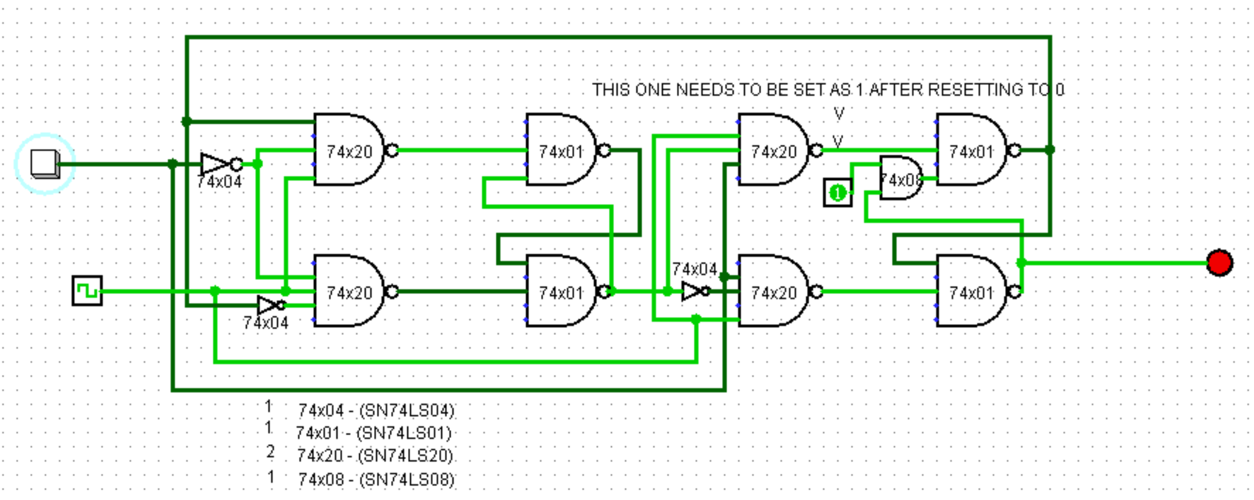

Problem 5.3

1. 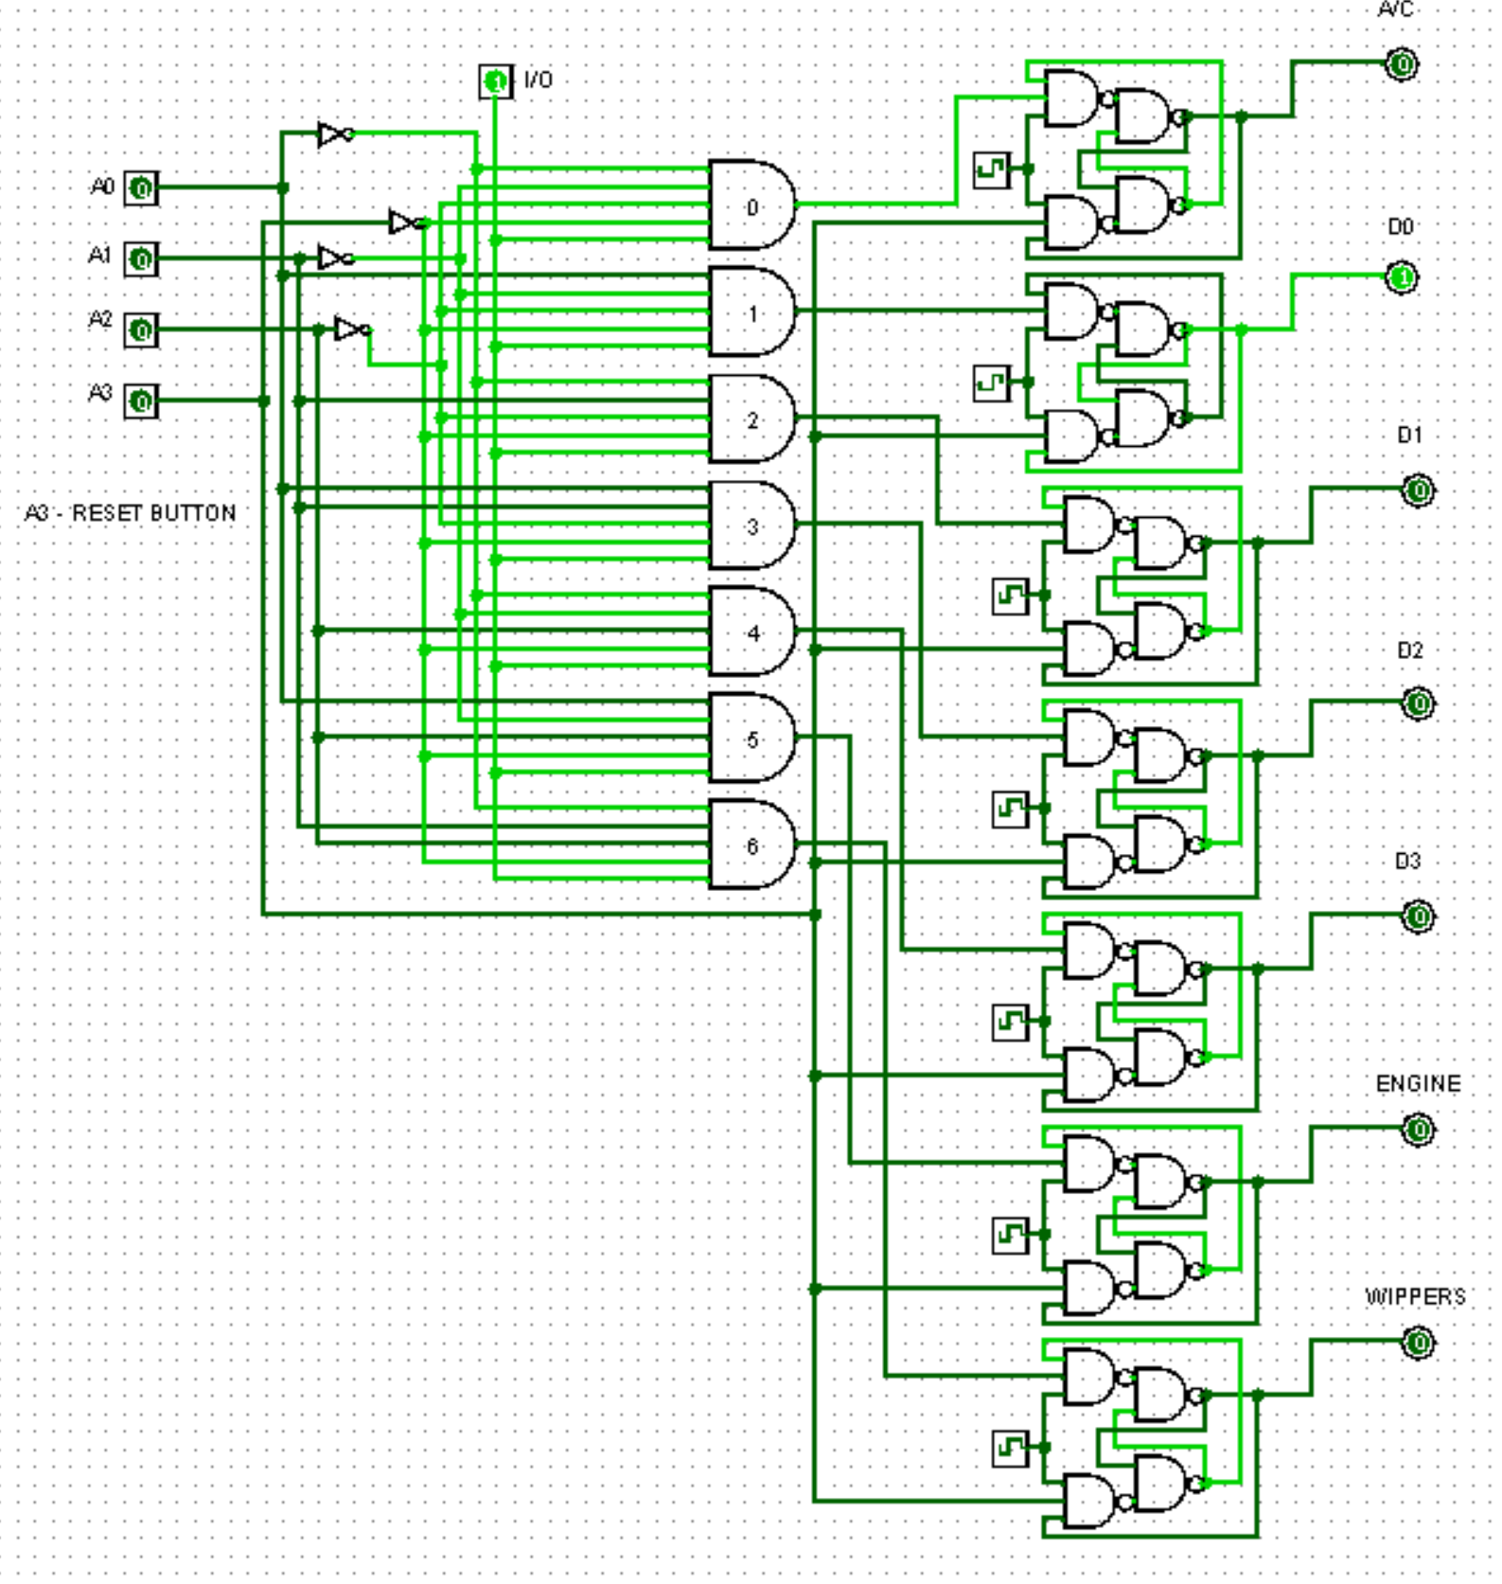
2. 